SYLLABUS 2021

MAJOR: |  | PSYCHOLOGY
COURSE: |  |  |  |  |  |  | Basic Processes II (attention & Perception)
INSTRUCTORS: |  |  | PEREZ CHADA/ BEIN
TOTAL HS/WEEK.: |  |  |  |  | 3 |  |  | TOTAL HS |  | 72
CAMPUS: | CENTRO |  |  |  |  | COURSES: |  |  | FM |  | SHIFT: | MORNING
YEAR: |  |  |  | 2020
URL:

BASIC | X | PROFESSIONAL

INSTRUCTORS:

Name | E-mail
DANIELA PEREZ CHADA | daniela.perezchada@usal.edu.ar
VICTORIA BEIN | bien.victoria@usal.edu.ar
JAUREGUIALZO, YVONNE | y.jaureguialzo@usal.edu.ar

Basic Processes belongs to the biopsychosocial area. It shares content with other subjects such as Neuroscience II & III, Developmental Psychology I & II, Introduction to the study of Science, Learning and Memory, Language and Thinking, etc.

This subject is based in the cognitive paradigm. It´s main goal is to study the cognitive processes of human beings, and how do they process information.

In order to achieve this goal, is important to make a history review such as: Science, concept, evolution by Thomas Kuhn, behaviorism: Watson and Skinner, birth of Cognitive Psychology, Mind modularity theory by Jerry Fodor, Theory of Mind by Premack &Woodruff, Memory, Attention and Perceptual Processes.

OBJECTIVES

Have students develop competencies and abilities to:

- Acquire knowledge on the various schools of Psychology that have made great theoretical and empirical contributions to the study of perception, memory and attention.

- Understand and critically discuss the current models that explain the basic cognitive processes.

- Be able to conceptualize a model of the psychological subject by integrating attention, memory and perceptual processes together with the rest of the cognitive processes studied by Cognitive Psychology.

- Become aware of the relevance of studying and conducting research on basic cognitive processes in different fields of application within psychology, especially education, clinical and industrial-organizational work. Students are expected to be able to retrieve the content and abilities learned in this class in future subjects, both basic and applied ones.

COURSE HOURS:

 | Theory | Field Work | Total
Total Hours | 72 | 0 | 72

BASIC UNITS AND READINGS:

UNIT Nº 1: PSYCHOLOGICAL SCIENCES

Main characteristics of scientific knowledge. The role of the psychologist when conducting research and doing field work. Basic and applied research.
Required Readings:
- Thomas, J. R., Silverman, S., & Nelson, J. (2005). Research methods in physical activity, 5E. Human kinetics. Chapter 1.

UNIT Nº2: A CHANGE OF PARADIGM: FROM BEHAVIORISM TO COGNITIVISM

Paradigm changes in North American psychology. The behaviorism revolution in psychology: from the conscience to behavior; from introspection to empirical methods. Premises and basic principles of behaviorism. The cognitive revolution: psychology’s study focus and cognitive sciences. The computer model and central processes. The computer metaphor. The methods used in cognitive psychology. Introspection, experimental methods and computing simulation. The architecture of the cognitive subject.

Required Readings:

- Braisby, Nick (2005). Cognitive Psychology. Oxford University Press. Chapter 1: Foundations of Cognitive psychology.
- Hunt, M. (2009). The story of psychology. Anchor. Chapter 9: The Behaviorists

- Hunt, M. (2009). The story of psychology. Anchor. Chapter 16: The Cognitivists

UNIT Nº 3: THEORY OF MIND

Mental skills. Theory of mind on anthropoids. Thetactical deceit. “False beliefs” experiment and theory of mind in children. Autism and development.

RequiredReadings:

- Carlson, Stephanie M(). Theory of mind
- Goswami, Usha (2008). Cognitive Development, The Learning Brain. Psychology Press. Chapter 3: Infancy: The Psychological World.
- Goswami, Usha (2008). Cognitive Development, The Learning Brain. Psychology Press. Chapter7: Social cognition, mental representation and Theory of mind.
- Rakoczy, Hannes (2017). Theory of mind.

UNIT Nº4: MEMORY

Memory systems according to the Multi Store Model: Sensory Register, Short-term Memory or Working Memory and Long-term Memory. Historical account of the first experiments developed in this field. Characteristics of each of the model’s subsystems. Memory as a basic process that articulates with every other process.

Required Readings:

- Braisby, Nick (2005). Cognitive Psychology. Oxford University Press. Chapter 9: Working Memory.

- Eysenck, Michael, W. Principles of Cognitive Psychology (2004).Psychology Press. Chapter 5: Short Term Memory and learning.

UNIT Nº 5: ATTENTION

The concept of attention. How attention relates to other cognitive processes. The orienting response. The main characteristics of attention: span, intensity, shifting and control.
Attention’s manifestations and determining factors. Selective, divided and sustained attention. Pre-categorical and post-categorical filter models. The psychotic listening technique. Limited resources model. The dual-task technique. Attention and conscience. Controlled and automatic processes. Automaticity and control empirical criteria. Habituation. Faux pas associated to automatic processes. Signs’ detection. Vigilance. Search. Attention and psychological intervention: health and education. Attention and psychological assessment. Introduction to neuropsychological assessment. Interviews. Tests and tasks’ selection.

Required Readings:.
- Eysenck, Michael, W. Principles of Cognitive Psychology (2004).Psychology Press. Chapter 4: Attention and pattern recognition.

- Schwartz, B. L., &Krantz, J. H. (2017). Sensation and Perception. Sage
Publications. Chapter 9: Visual Attention.

- Watson, Neil V, Breedlove, S.Marc,The Mind´s Machine, foundations of brain and behavior, chapter 14: attention and Consciousness. Sinauer Associates, Inc. Sunderland, Massachusetts 2012.

UNIT Nº 6: PERCEPTION

The fundamental problem of perception. Theoretical models of perception. The constructivist model. The nativist model. The psychophysiological model. The information processing model. Models of shape perception: model of comparisons between templates, model of analysis of characteristics, model of structural descriptions. Theories of object recognition. Marr and Nihishara’s theory. Biederman’s theory. Vision understood as a computing process. Marr’s computational theory of vision. The connectionist approach to shape recognition. Fodor’sTheory of Modularity.

- Braisby, Nick (2005). Cognitive Psychology. Oxford University Press. Chapter 17 part 3: Theoretical Issues in cognitive Psychology: modularity.
- Schwartz, B. L., &Krantz, J. H. (2017). Sensation and Perception. Sage
Publications. Chapter 1: What is Perception?

- Schwartz, B. L., &Krantz, J. H. (2017). Sensation and Perception. Sage
Publications. Chapter 5: Object Perception.

LEARNING RESOURCES:

The class will be based on both lectures and applied assignments or discussions. During the first part of the class, the instructor will lecture the content specific to each class, and on the second part, students will work individually or in groups on the recently learned concepts. Work in groups will be based on specific analysis and concept articulation techniques (for example discovery matrices, semantic nets, work on particular clinical cases, oriented reading of previously selected texts, among others). The use of these techniques is intended to promote students’ significant learning of the course’s material. Instructors will ensure students’ identification and discussion of the dilemmas presented in each area, in order to avoid a passive assimilation of the exposed content. At the end of each class the instructor and students will draw the main conclusions for each content area, based both on the lectures and students’ group work.

COURSE REQUIREMENTS:

There will be two midterms. One will be individual, written and in a multiple choice format. The other one will be a group oral presentation about a topic given previously in class. They will take place during the 8th and 13th week of the semester. Each respective make-up exam will take place during the week following the respective midterm, according to the university’s general regulation.

Classroom Etiquette
You are asked to arrive on time. There will be a tolerance of 15 minutes late, not more. Cell phones and other mobile devices should be turned off or silenced upon entering the classroom. They should de stowed away during class time. If you have an emergency that requires you to keep your phone on, please inform me at the beginning of the class.
Conversation with other students during lecture can also be distracting to others. If you have a question relating to lecture, fell free to interrupt me.

FINAL EXAM
The final exam will be individual and could be oral or written, depending on the instructor’s criteria. It will include all the required readings in this syllabus, even if they haven’t all being included in the lectures during the semester.

SCHEDULE:

WEEK | UNIT | HOURS | THEORY | PRACTICE | TESTS
1
2 | Class 1  Course introduction. Syllabus explanation. Lectures.  Introduction to Research. Developing the problem and using the literature.
3 | Class 2  Story of Psychology: Behaviorism.
4 | Class 3  Story of Psychology: Cognitivism
5 | Class 4  Theory of Mind
6 | Class 5  Theory of Mind
7 | Class 6  Memory: Multi Store model. Working memory.
8 | Class 7  1st EXAM
9 | Class 8  Neuropychology. Executive Functions.  Attention and consciousness
10 | Class 9  Attention and Pattern recognition. Visual Attention
11 | Class 10  Perception.
12 | Class 11  Object Perception. Modularity of mind.
13 | Class 12  2nd EXAM: Oral Presentation
14 | Class 13  Revision before final exam.  End of course.

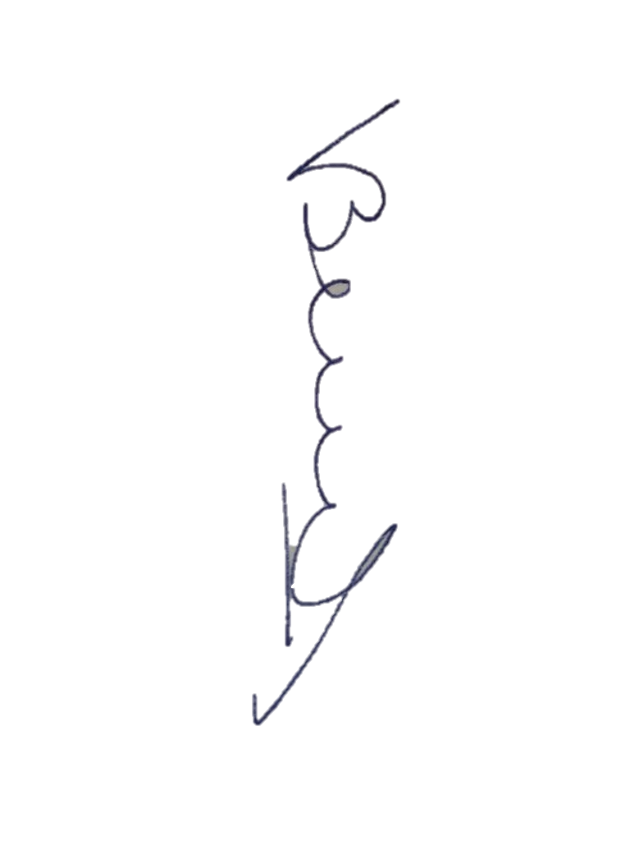

INSTRUCTOR´S SIGNATURE:
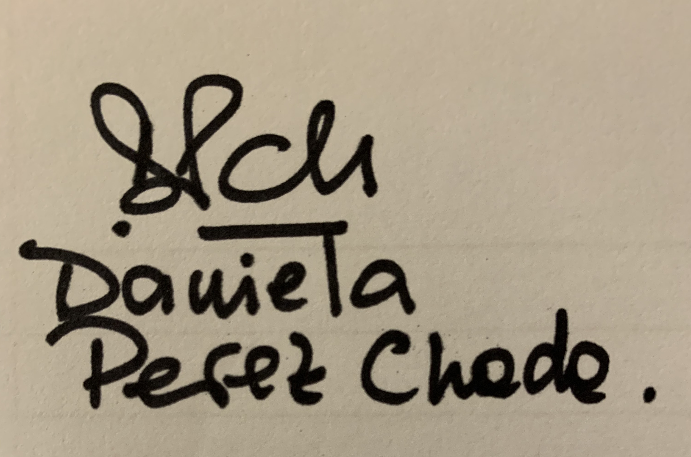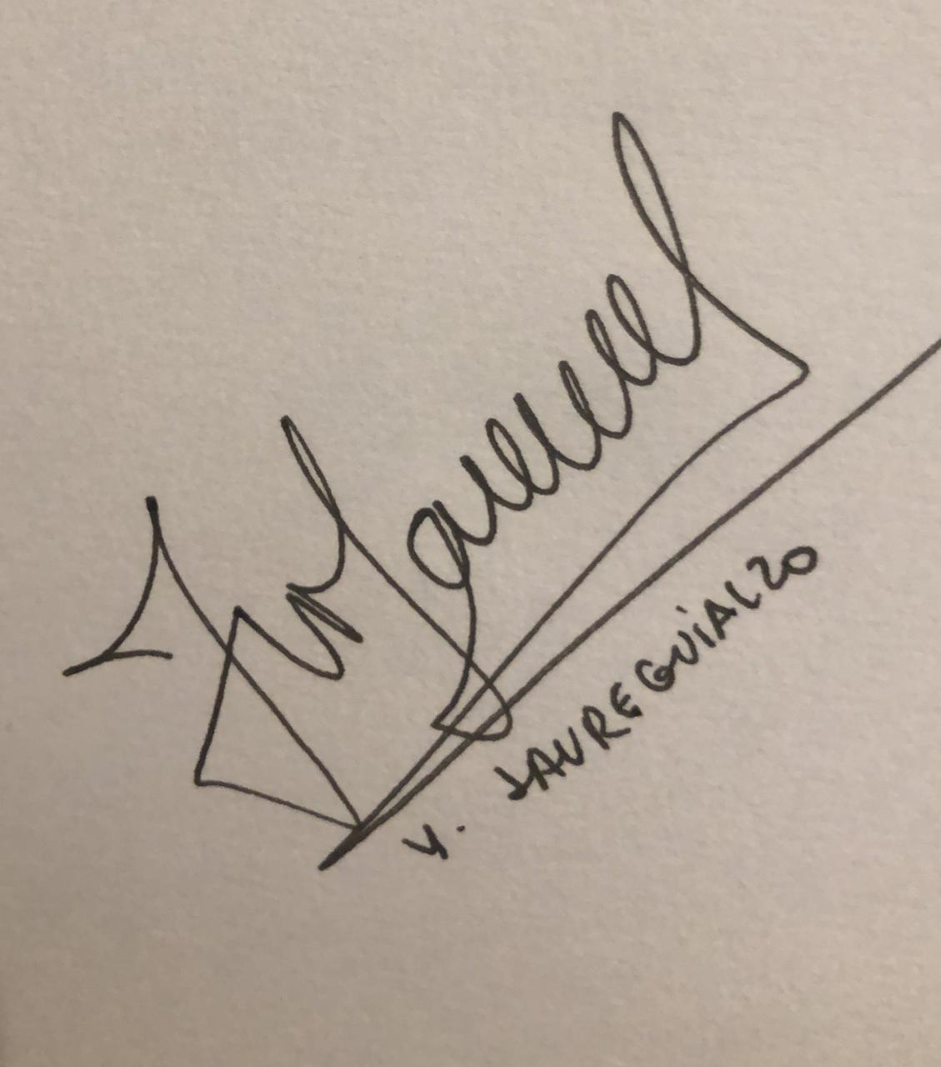

Daniela Perez Chada Victoria Bein Yvonne Jaureguialzo

CHAIR`S SIGNATURE:

